**CS5590 VC – Lab 2 Koushik Tammineedi**

Created a mobile application using JS Fiddle, Jquery Mobile(JavaScript), Html, CSS for Lab 2 Assignment

This Client application can be used for getting directions between two places and the weather at the two place and also getting the weather conditions from a place using RESTful Web Service. It serves four functions:

1. Getting directions from one’s current location or from any location to Destination location.
2. Obtaining current weather data and displaying the weather layer on top of the map itself.
3. You can select the transportation mode that you prefer.
4. Gives the detail waypoints to reach the destination from the starting location.

I used Google Map APIs to obtain directions and weather by utilizing the Directions Service and view the map using the DirectionsRenderer. For the weather application, I used google API weather Library which serves the same purpose as the weather services.

Steps:

User is at the main page, they can click the button for getting directions from a location to the target destination and also the weather is displayed on the fly. Note at any time the user can click the Home button to go back to the main page.

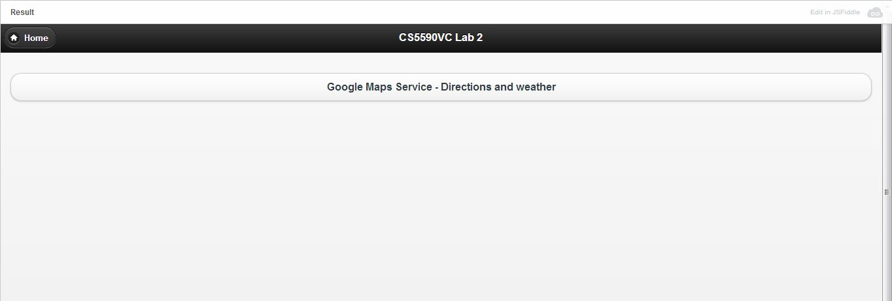

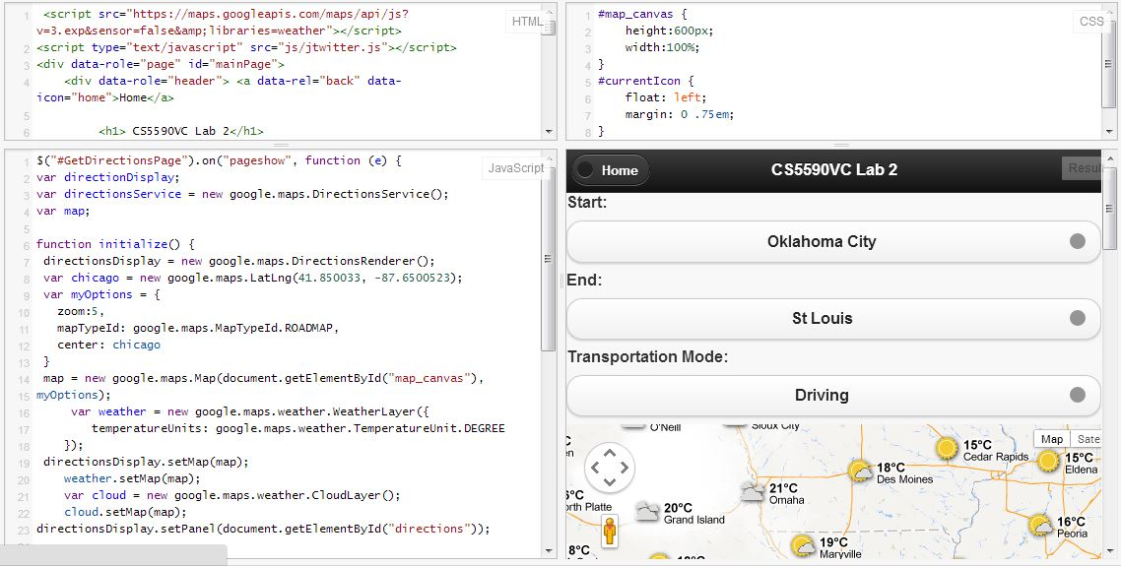

User clicks the Directions button for a Google Map containing the dropdown list of starting location and destination locations and options to choose the transportation mode. Upon which the map is updated for every change of selection in the drop down list of source, destination and travel mode.

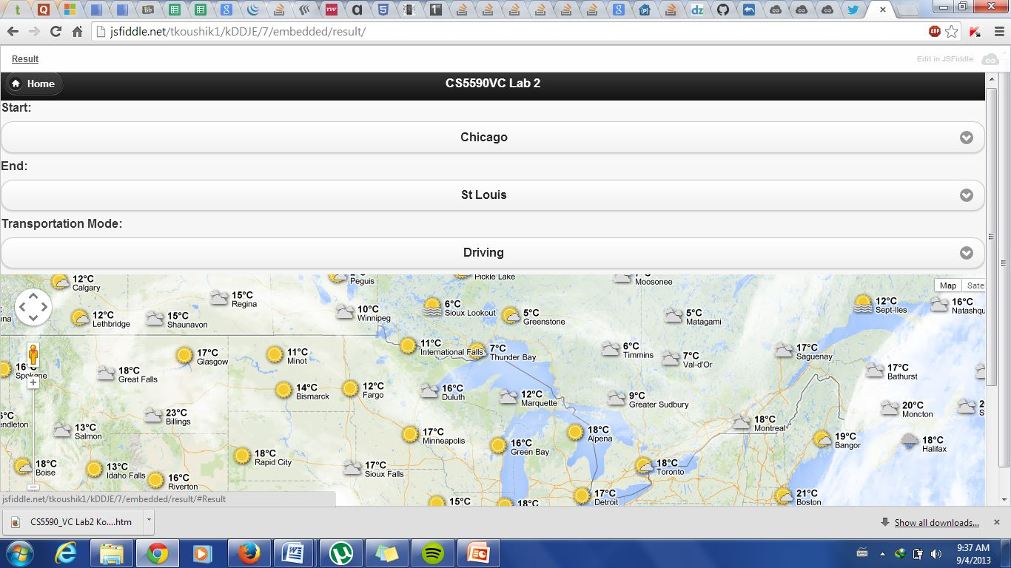

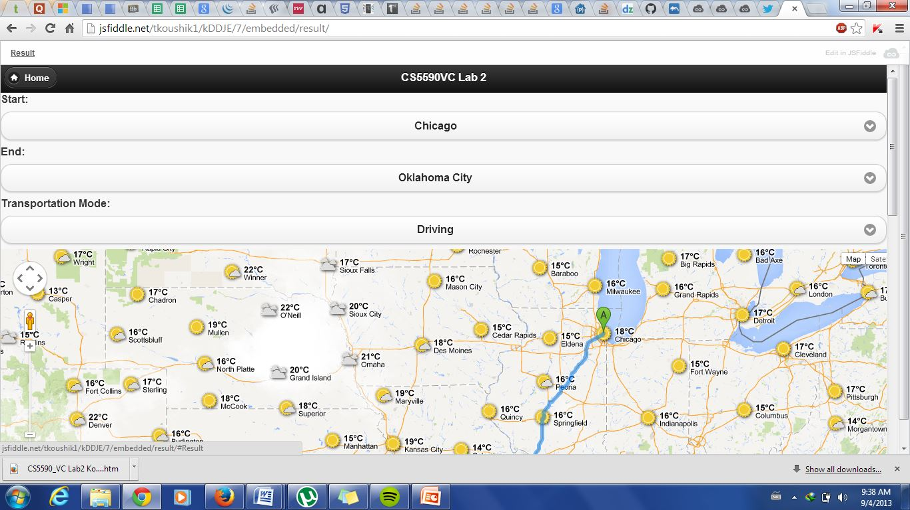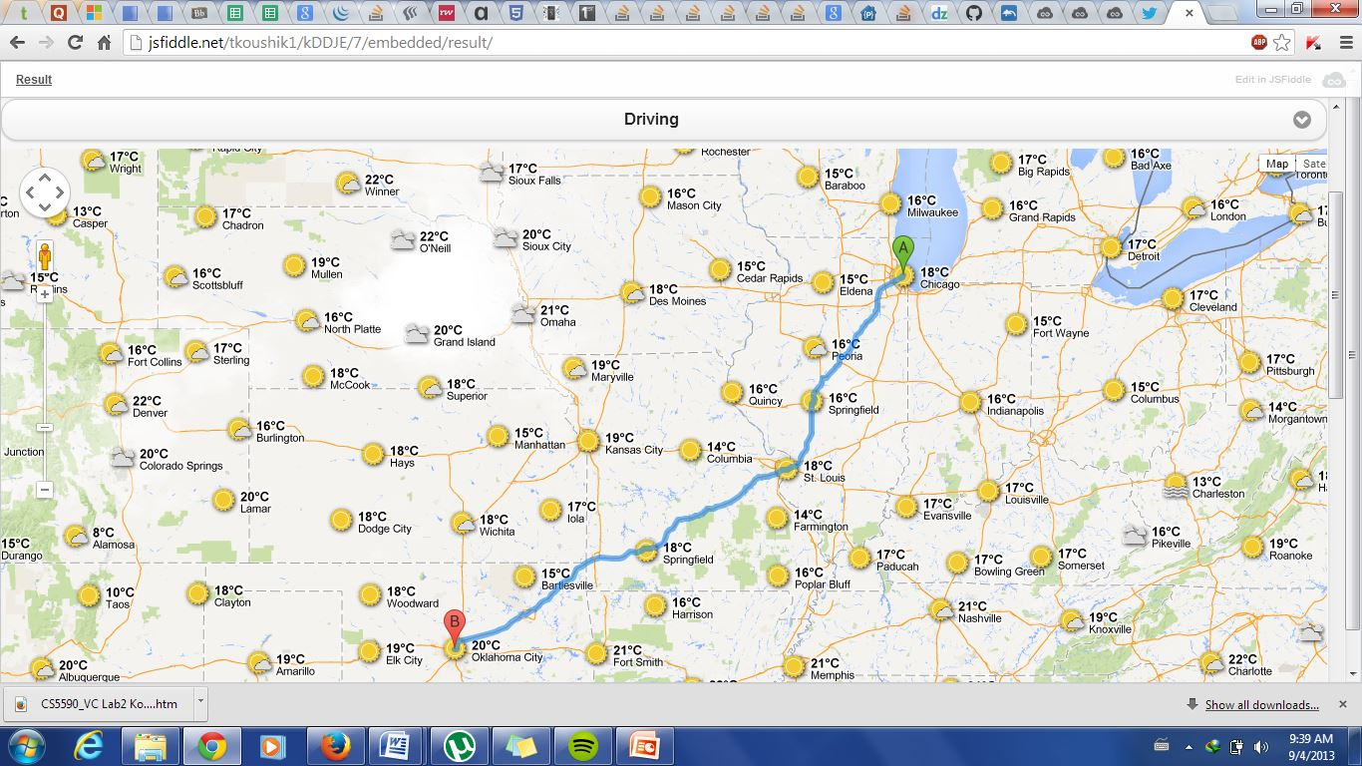

User Can also Get detailed waypoint on how to go from source to destination.

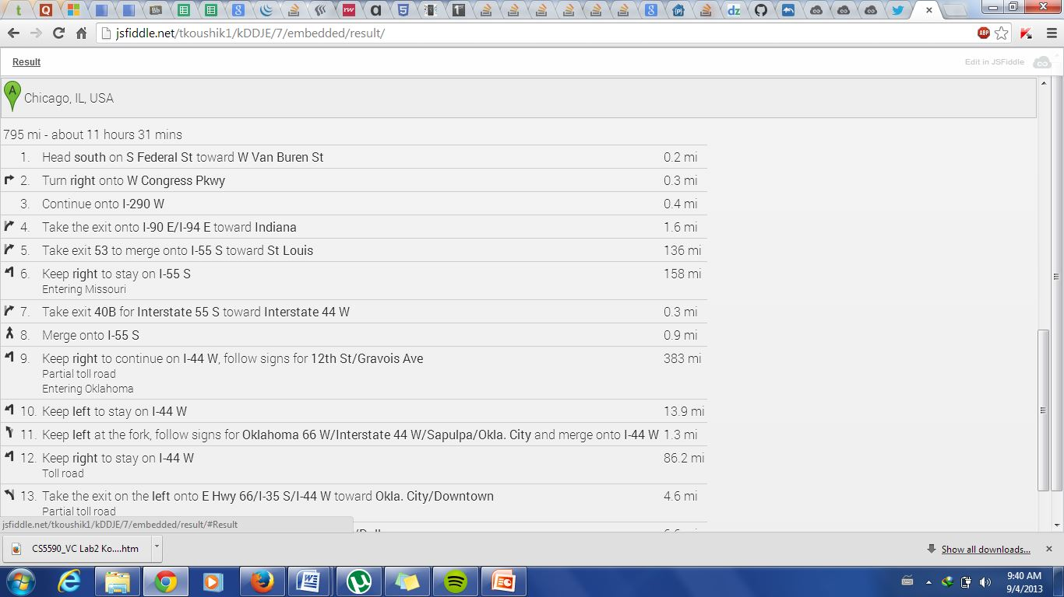

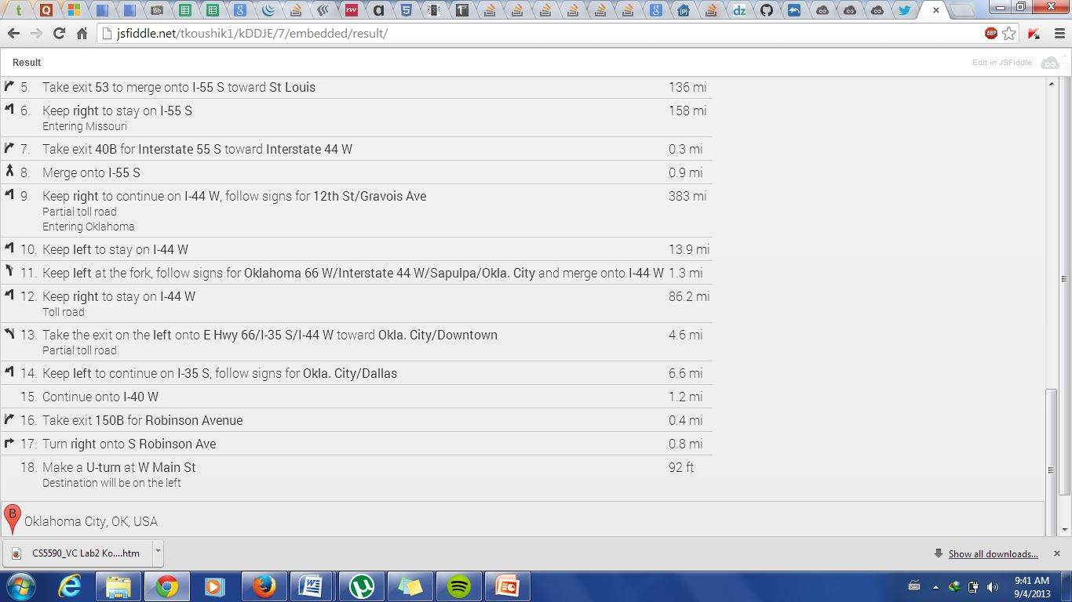

User can also change the mode of his transportation 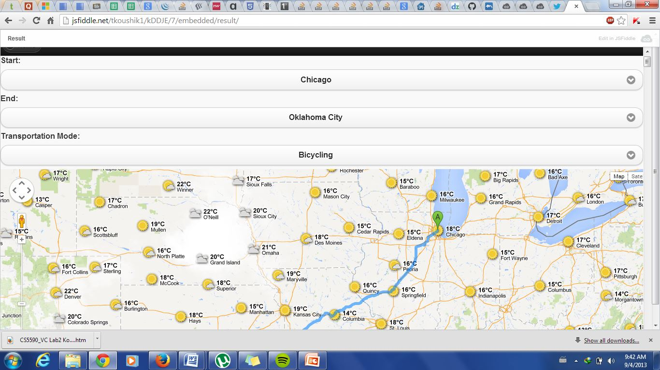

After user selecting his mode of transportation an event is triggered on selection and the route is recalculated and new waypoints are generated.

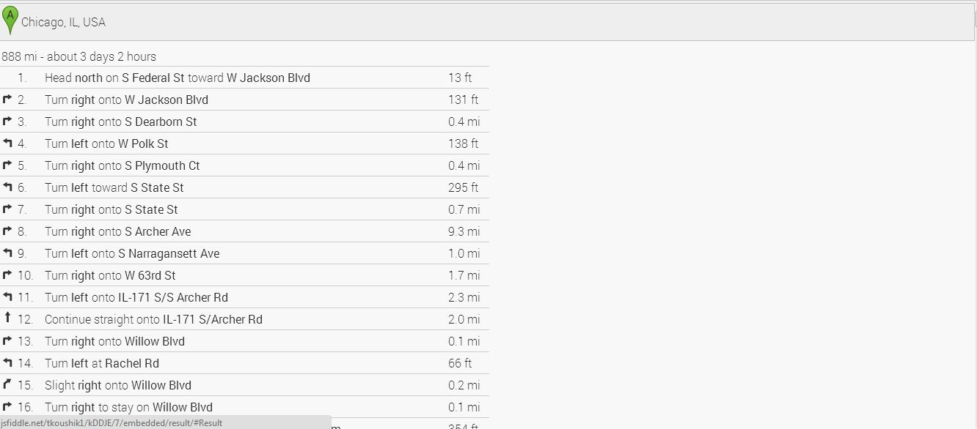

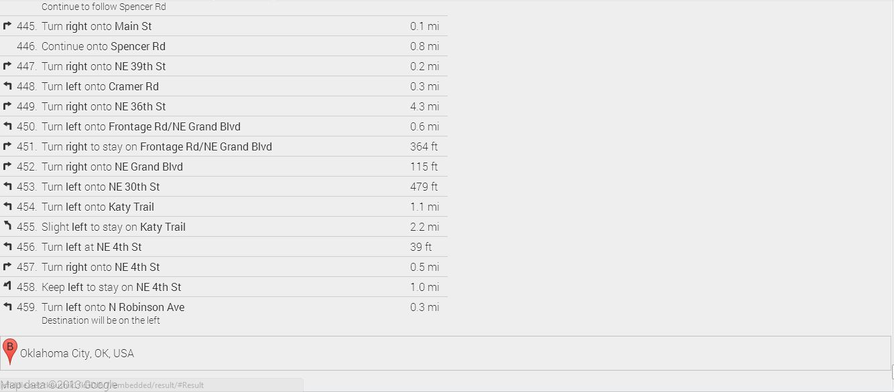

Another Client application is getting the Weather conditions from a particular place by consuming the webservices and parsing the JSON data returned by the service and displaying it to the User.

